TASK 01:

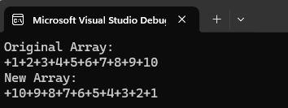

TASK 02:

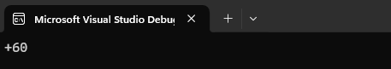

TASK 03:

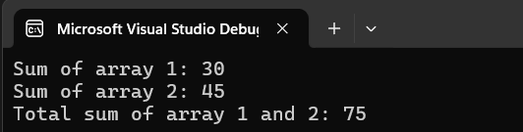

TASK 04:

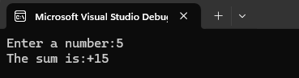

TASK 05:

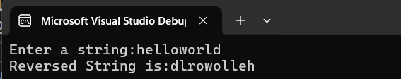

TASK 06:

